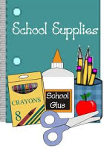4th Grade Supply List
Some materials such as pencils/glue will be used as community classroom supplies!
- 1 package of Ticonderoga Pencils (they sharpen the best)
- 2-4 white board markers (no Crayola, they do not erase well)
- 1 pair of scissors
- Glue sticks (at least 2)
- 1 packs of 3 x 3 post it notes
- 1 pack of colored pencils, crayons or markers
- Zipper pouch toolkit (they fit in our supply drawers, the boxes will not)
- Earbuds/headphones
- 2 containers of Clorox wipes
- Individual/Personal Water Bottle
- 2 composition notebooks
Optional Classroom Donations:
- Tissue
- White Paper Towel
- Class Snacks
- Loose leaf paper
- Ziplock bags (gallon and quart size)
- Hand Sanitizer

