Hello Everyone,

It is February and we have finished up our NWEA testing with all the students. I am so pleased with the growth they have made, having over 90% of the students making growth. It is wonderful to hear the students come out of a testing session excited to tell the staff their scores. The pride the students have is incredible.

We had such a fun time at our annual Science Family Night. The teachers had several cool experiments to try out in each of the classrooms. Students were able to see how many pennies it would take to sink a tinfoil boat, experiment with non-Newtonian fluid, experience what happens when you put a bar of soap in the microwave, and many other hands-on experiments. A big thank you goes out to John Kish from Mio for his extraordinary science presentations and Joy Brooks from the DEQ who helped the family construct a flood plain! Both these people brought a new perspective to our evening.

Be sure to enjoy our Rose City School’s Reading Month Kick-Off Family Night. We will be having Co-Authors, Charles David Clasman and David Anthony join us for a MYSTERIOUS presentation about their Real Hero books. Charles and David are Michigan Authors who write mysteries and adventures that excite kids of all ages!

Have a Great February!

Ms. Smith

Upcoming Events
Parent/Teacher Conferences
Feb. 11 & 12

No School
Feb. 13 & 16

PTO & FOR Club Meeting
Feb. 17th at 4:00 p.m.

Family Night- Reading Month Kick-Off – Author Presentation
Feb. 24th from 5:00-6:30 p.m.

PBIS Assembly
Feb. 27th at 3:00p.m.

515 S. Harrington
Rose City, MI 48654

Mailing: P.O. 308
West Branch, MI 48661

Phone: 343-2248
Fax: 343-2299

February 2015

Rose City School Newsletter

P.T.O. Carnival
We Need You! We are in great need of volunteer help for our annual P.T.O. Carnival. This is an event that many look forward to all year long. If you could help with: set up, clean up, money collection, running a game or more, please contact Brandy Breining at breininb@wbrc.k12.mi.us or 343-2250 ex. 6007.

PTO Meetings/F.O.R. Club Meetings
Meetings are held every 3rd Tuesday of the month in the
RCS Media Center
Feb. 17th @ 4 p.m.
Mar. 17th @ 6 p.m. Apr. 21st @ 4 p.m.

Principal’s News

Jill Smith
Principal

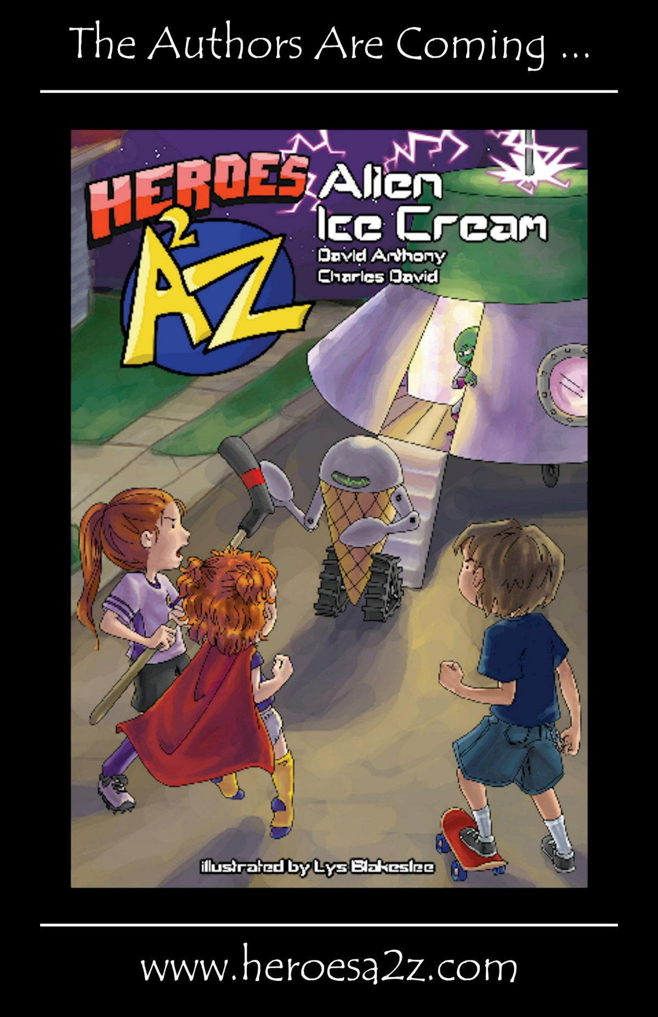

JOIN US FOR FAMILY NIGHT! FEB. 24TH FROM 5:00-6:30p.m.

PLEASE JOIN US!
5TH &6TH Grade
Parent & Child Dance
February 6, 2015
6:00 p.m. to 8:00 p.m.

$5.00 per person

Money raised will help fund the 6th Grade Camp Trip!

Page 2 of 2
School Newsletter

Old Man Winter is still here!
Please dress your children for the colder weather, in
a warm coat, gloves, hats, and boots.
If you’re in need of any of the above items please contact
Ms. Hofer, Counselor, at 343-2282

Rachel’s Challenge
Rose City School continues to embrace the principles of Rachel’s Challenge, by:
- Using Kind Words
- Doing Nice Things
- Including Others
- Starting Your Own Chain Reaction
From creating our own chain link strung from the hallway ceiling to catching kids making extraordinary things happen, we are creating a CULTURE OF KINDNESS AT ROSE CITY SCHOOL!
PASS IT ON!

PBIS Assembly

On February 27th the assembly will begin at 3 p.m. and we encourage everyone to join us.
We would like to thank the following local businesses for being a sponsor for the PBIS assembly:
January- Chemical Bank
February-Mercantile Bank

Attendance Challenge for the month of February

Each day your child’s classroom has 1 student or less absent for that day, we will fill out a Valentine’s Day card for the classroom, which will be put into a drawing at the end of each week for a classroom prize.

Box Tops for Education
During the month of February there will be a box top competition between the 1/2 grade students and the kindergarten grade students. Let’s see which group can collect the most!

Please go to the school’s website for more information
www.wbrc.k12.mi.us/our-schools/rose-city-school/

